Range of a Function

At this point we should understand that the “domain” of a function is the set of values that can be used as arguments for that function. That is, the “domain” is the set of values that we give to the function. For each value that we give the function, that function returns a value. The set of all possible returned values generated by the different “domain” values is called the “range” of the function. Consider the following diagram of a function machine:

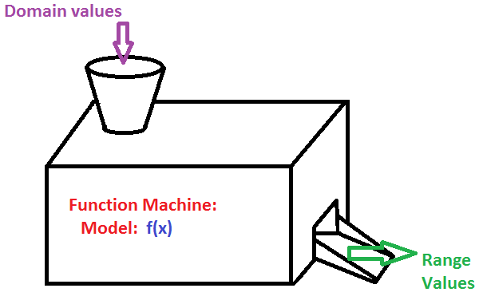

We give the function machine a value, we will call it “x”, and the function machine does its work and produces, as output, a value which we might call “y”. “x” is part of the domain and “y” is part of the “range”. In general, we write this as y=f(x), meaning that when we use x as the input of the function then the output is equal to “y”.

For example, we might have a function that accepts numbers as input, doubles the number and then adds 1 to get the output of the function. If we limit the domain to the numbers 3, 5, 6, and 11, then the range for that limited domain becomes 7, 11, 13, and 23; double 3 and add 1 gives 7, double 5 and add 1 gives 11, double 6 and add 1 gives 13, and double 11 and add 1 gives 23.

As a second example consider a different function that accepts numbers as input, subtracts 4 from the input value and then squares the result to produce the output. For this function if we limit the domain to 1, 3, 5, and 6 then the range is 9, 1, and 4. Note that if the input is either 3 or 5 then we get the same output value, namely 1. It is quite appropriate to get the same output value for different input (i.e., domain) values.

As a third example, consider the function that accepts as input any student registered at Washtenaw Community College in a credit class for some particular semester. The output of this function is the age of the student, in completed years, on the first day of the semester. For a particular term it is entirely possible that the “range” of this function will be the numbers 14, 15, 16, 17,…,67, 68, 72, 74, 78, and 81. We would have many students whose age is 19 but there may be only 1 student whose age is 72, and no students whose age is 69, 70, 71, 73, 75, 76, 77, 79, or 80. We can tell from the range that there are no credit students younger than 14 and no credit students older than 81, at least for this hypothetical term.